Kruskals MST

***1.*** ***Kruskals MST***: Implement the following API for finding the using Kruskals MST.

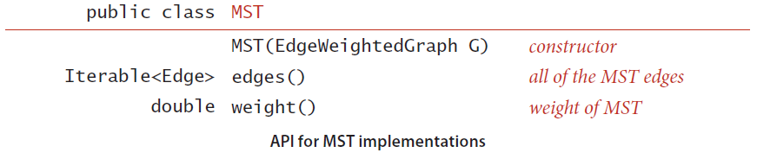

**Input Format:**

* The first line of the input contains the number of vertices.
* The second line of the input contains the number of edges.
* There are E lines from the third line where each line has two integers and one double value indicates an edge between v and w and its weight that are separated by spaces.

**Output Format:**

* Print the edges that are added to the MST along with its weight.
* The last line of the output contains the total cost of the MST.

**Note:**

* You can use Edge and EdgeWeightedGraph from the first question.
* Please check for the sample input and output files given in the folder.
* StdOut.printf("%.5f\n", mst.weight()); use this to print the weights of the MST Edges.

**Sample Input #1:**

**8**

**16**

**4 5 0.35**

**4 7 0.37**

**5 7 0.28**

**0 7 0.16**

**1 5 0.32**

**0 4 0.38**

**2 3 0.17**

**1 7 0.19**

**0 2 0.26**

**1 2 0.36**

**1 3 0.29**

**2 7 0.34**

**6 2 0.40**

**3 6 0.52**

**6 0 0.58**

**6 4 0.93**

**Sample Output #1:**

**0-7 0.16000**

**2-3 0.17000**

**1-7 0.19000**

**0-2 0.26000**

**5-7 0.28000**

**4-5 0.35000**

**6-2 0.40000**

**1.81000**